MISTHAVEN - GAME THEME/ IDEAS:

17 JAN 2014 – Aaron Alphonso

Screen size has the feel of a traditional Gameboy, smaller in size, pixels are more detailed and view field of the map is smaller. This will give an exploration feel while moving around the map.

**MENU SCREEN IDEA:**

Opaque black layer with 20% transparency, behind which is just an image of the hometown moving slowly in a circular path or any other path specified.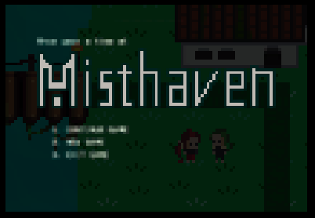

*< Intended original size (x370%).*

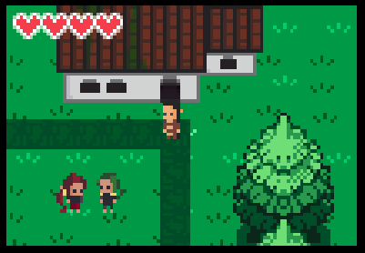

Concept for what the game could look like above. UI is very minimal, only health bar. Damage will be caused by traps and the AI monsters etc. during puzzle solving.

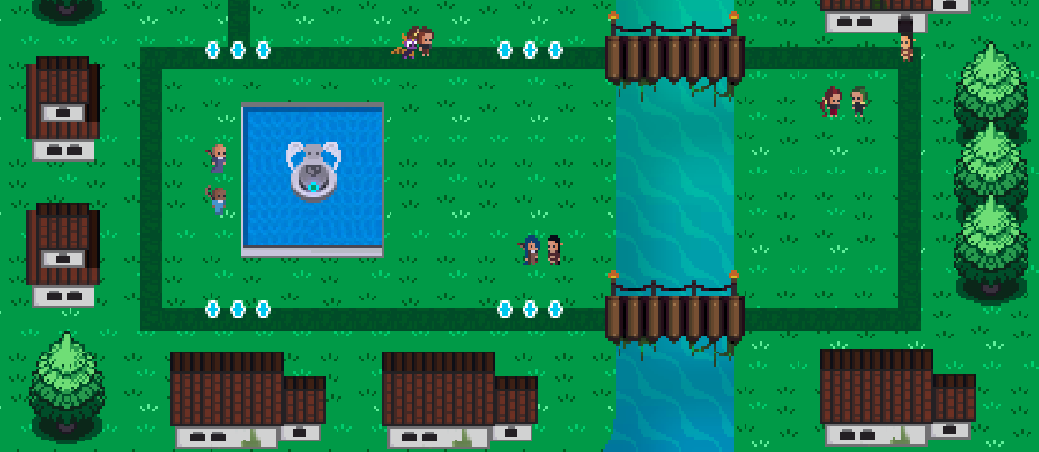

*Since the view field is small the player will feel like the map is much bigger than it seems. Above is the remake of the hometown mist haven. The portal, construction of the gate, evil NPCs etc have not been added yet.*

**OTHER IDEAS:**

* House will be main save point for the game. (Future implementation) player may even be able to choose an appearance in wardrobe, hair style, clothes, and some colors.
* The NPCs in the game will say random backstory/random humor/tips selected at random from a text file or a folder of dialogue sprites.
* We need to rethink about the value of Plasma (currency) and how we’re going to utilize it in the puzzles. Ether we take out the mechanic entirely or we just keep it as a form of scoring system, like collecting plasma in puzzles in optional hard to reach areas.
* We need to think about making the hometown more content packed. Maybe have some simple vendors that takes plasma for an extra life slot (heart), permanent walking speed increase. (We should avoid the whole selling junk/bags/inventory mechanic; we simply have vendors to alter some global variables of player attributes.
* This may be taking it slightly far for now, but I thought about having a couple of minigames in the hometown. THIS IS ALL SECONDARY for now. But it is surely possible and it will impress the profs. We use only open source code like “Snake” “X and O” and we literally just run it in our game as it if were part of the game. Imagine talking to an npc, and he says something like Hey ! want to play X and O with me? Or you walk to to an arcade machine and you play a simple game of brick pong.